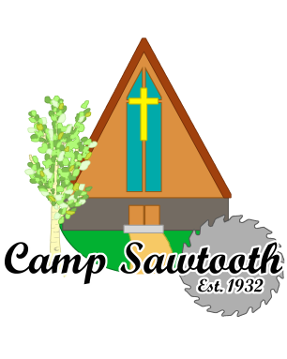
Camp Sawtooth
HC 64 Box 8290
One hundred North Fork Canyon Road
Ketchum, ID 83340
(208) 726-1155
directorscampsawtooth@yahoo.com ~ www.campsawtooth.org

To: Churches of the Boise & Kendall Presbyteries

From: Kevin Dutcher
Director
Camp Sawtooth

Re: Summer Camp 2022 Information

Date: April 12, 2022

Greetings from Camp Sawtooth!!

Attached please find resources for you to use for Summer Camp Recruitment. This file contains:
- A page of Newsletter and/or Bulletin snippets. Use as you see fit!!
- A ‘Cover Page’ that can be used as a Bulletin Insert and used as the Resource Guide Cover Sheet
- The Resource Guide – All the Information Needed to Register and Attend Camp Sawtooth in the Summer of 2022
All this information can also be found on our website:
WWW.CampSawtooth.org

If anyone has questions or problems…please have them reach out to me at:
DirectorsCampSawtooth@yahoo.com

Early Registration Discount ends on Saturday, April 30th, 2022.

Scholarships are available at most churches and if more scholarship monies are needed, please contact me. We do not want any child denied the opportunity of attending Camp Sawtooth this Summer!!

Thank You for your continued Support of the Mission & Vision of Camp Sawtooth!!

